# 邮件过程

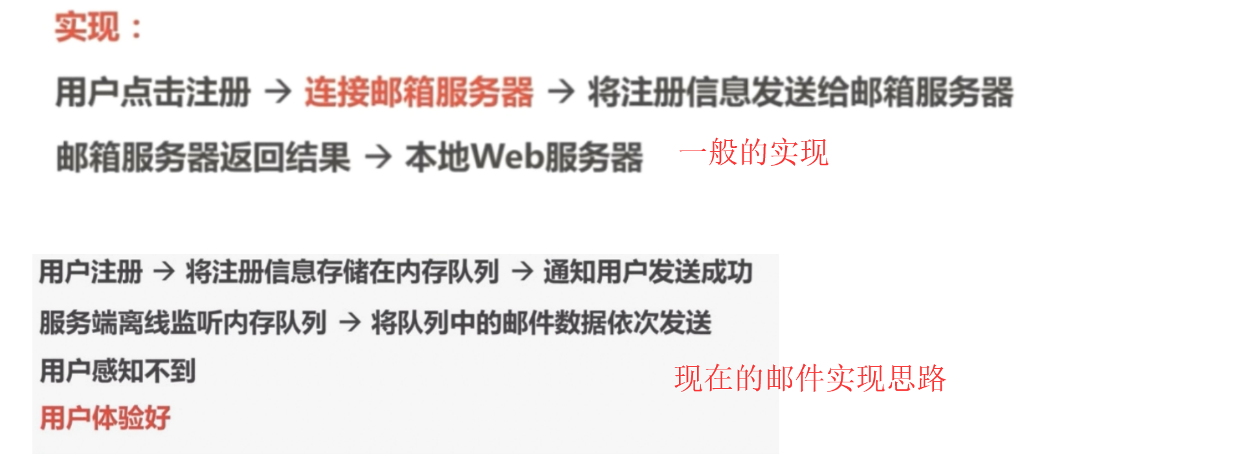

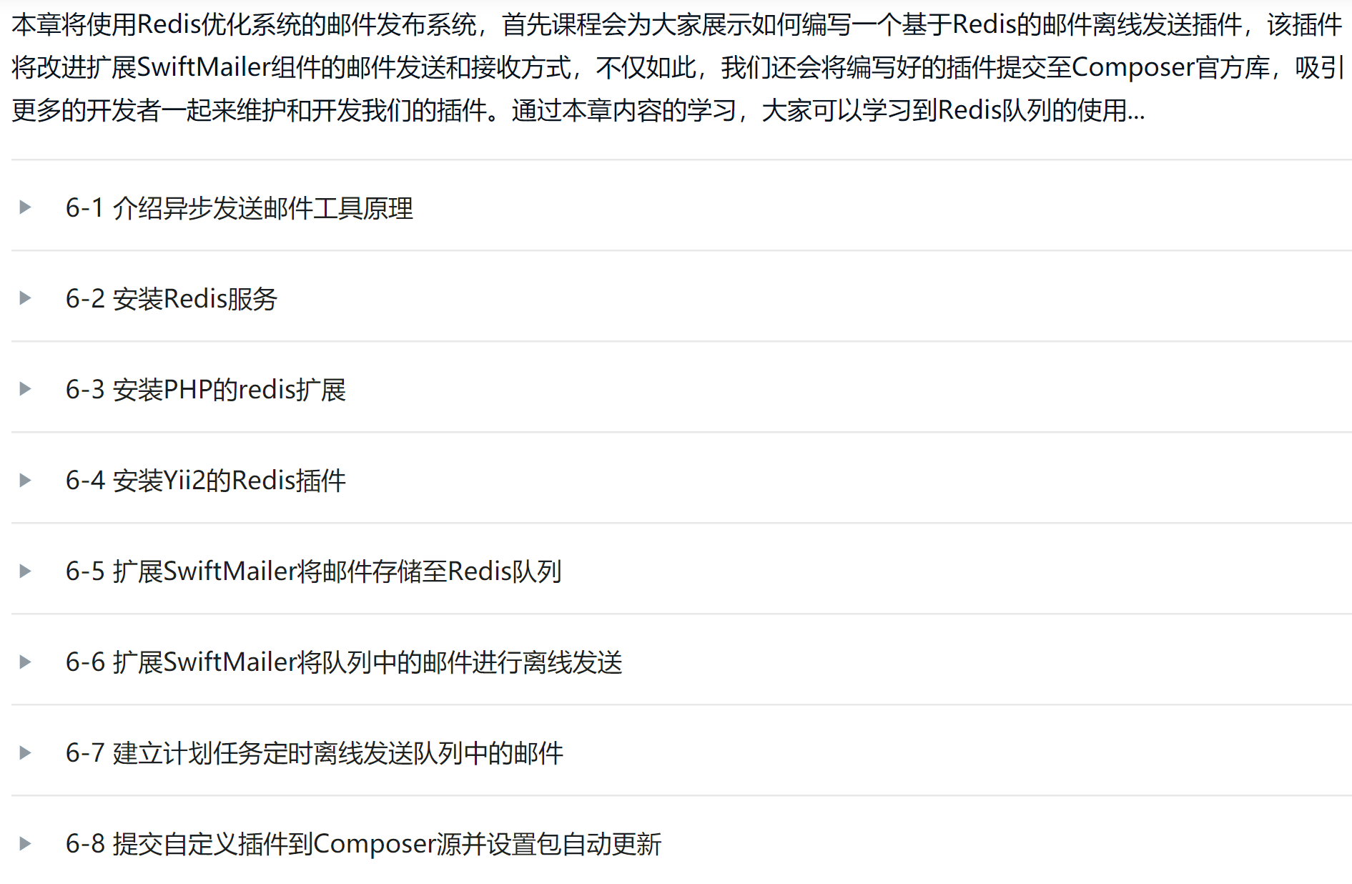

# Redis安装

$ wget http://download.redis.io/releases/redis-2.8.17.tar.gz

$ tar xzf redis-2.8.17.tar.gz

$ cd redis-2.8.17

$ make

$ cd src

$ ./redis-server ../redis.conf

$ cd src

$ ./redis-cli

redis> set foo bar

OK

redis> get foo

"bar"

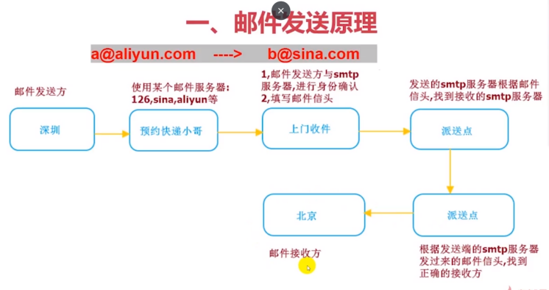

# Telnet模拟邮件

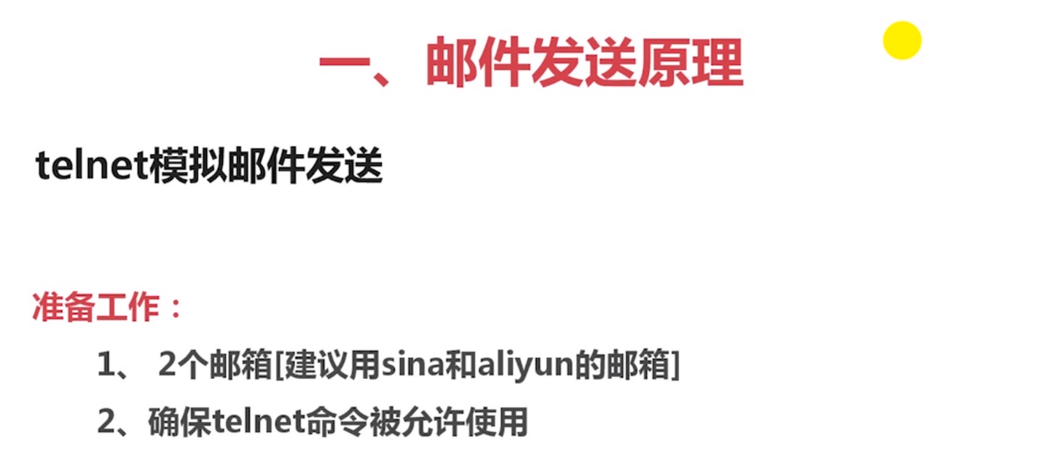

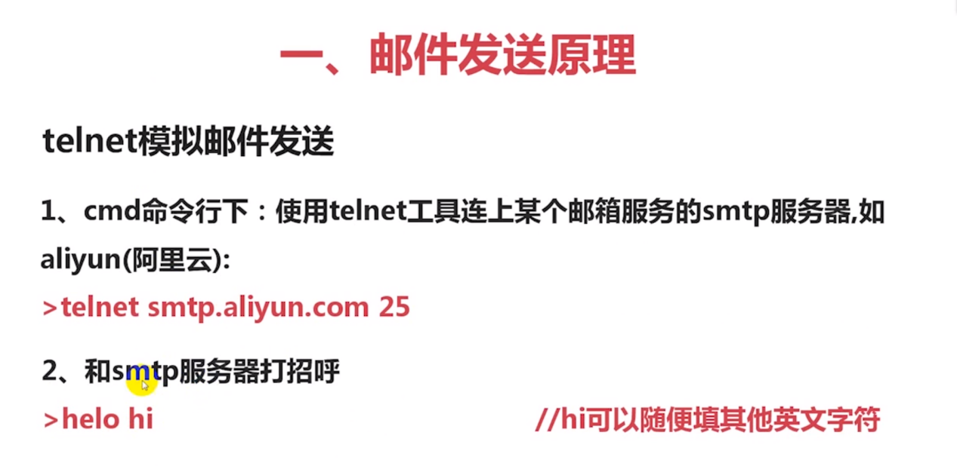

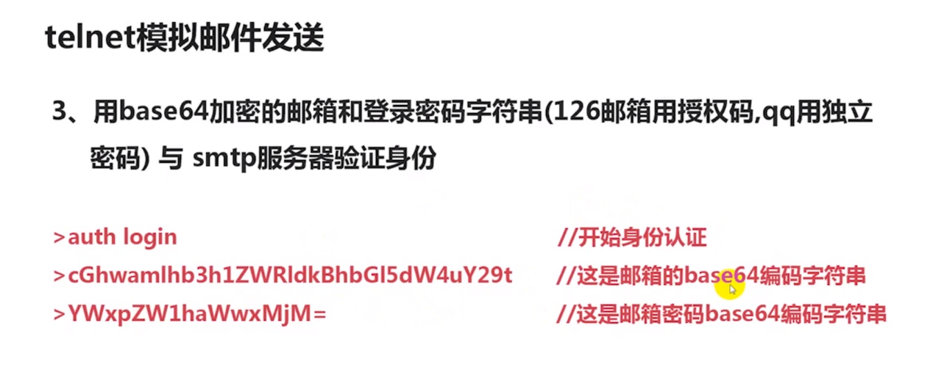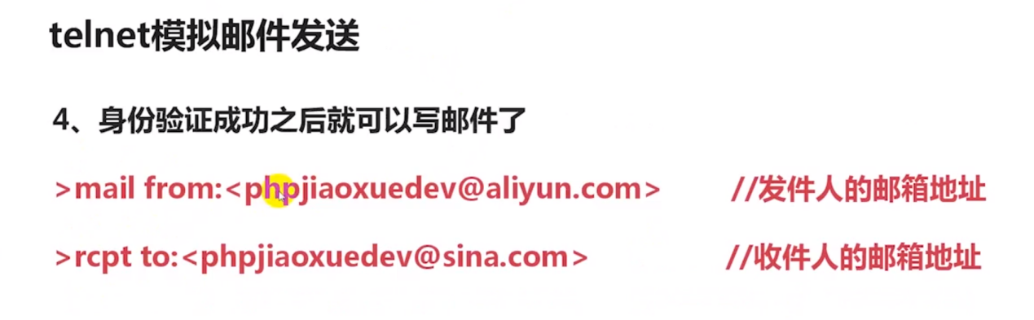

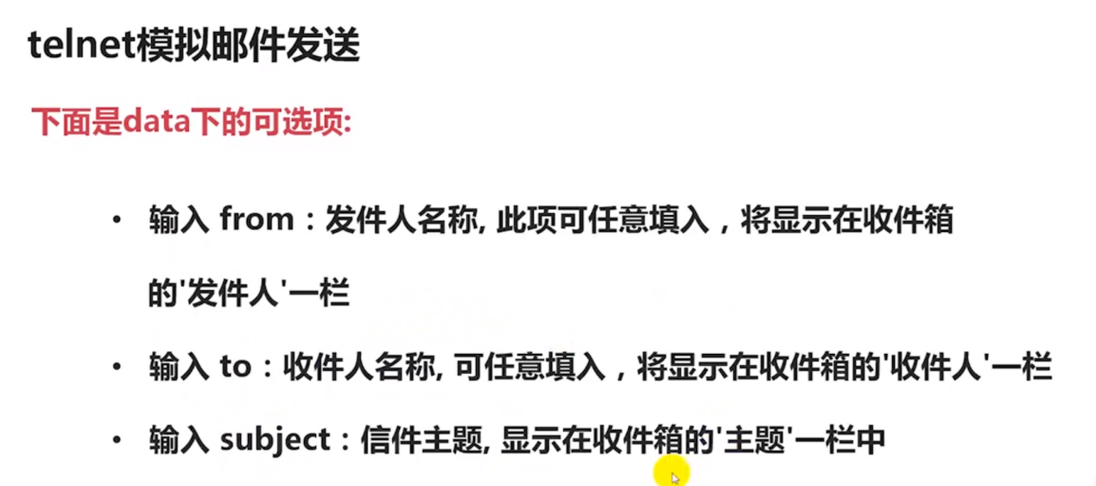

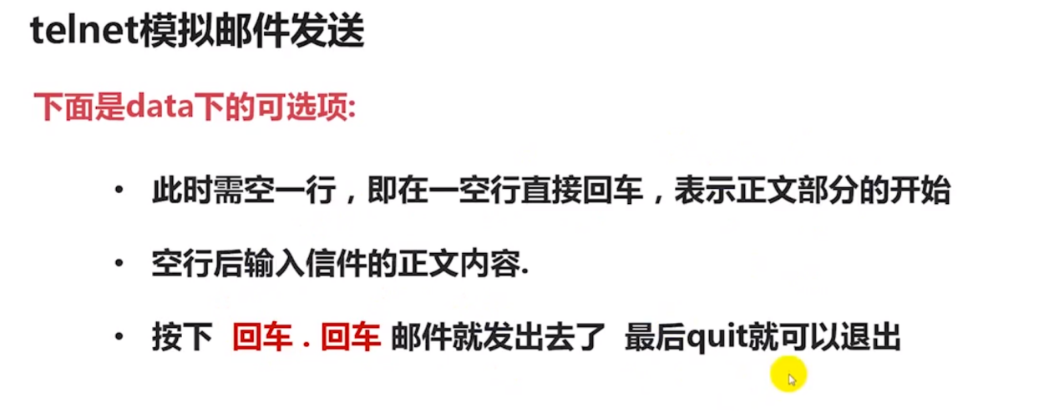

# 实际操作



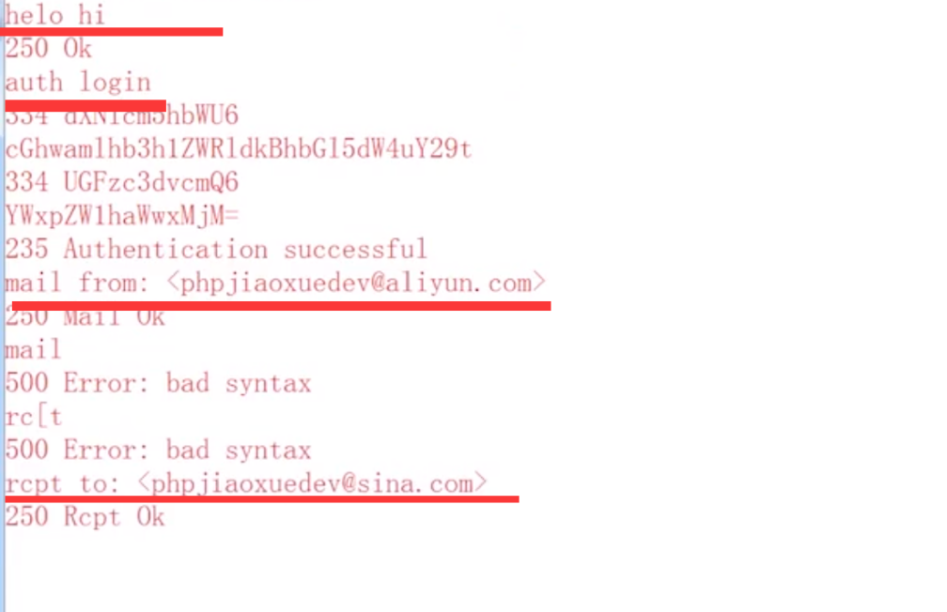

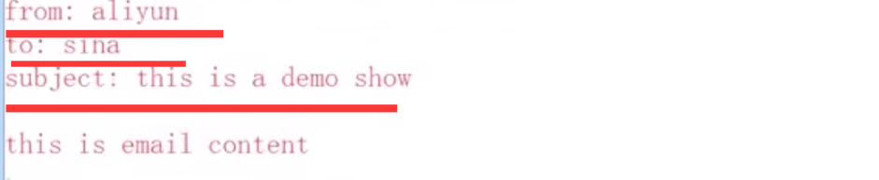

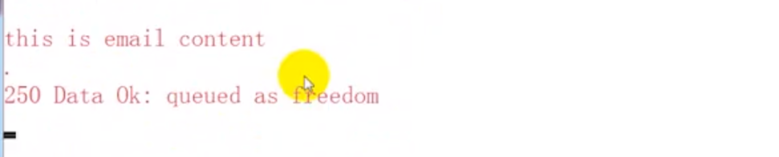

# 这样的缺点



# 改进思路

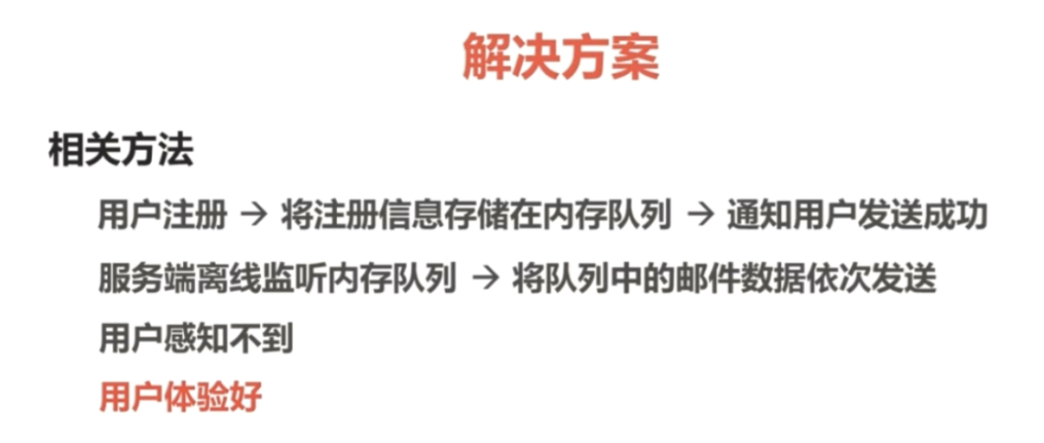

# 邮件思路

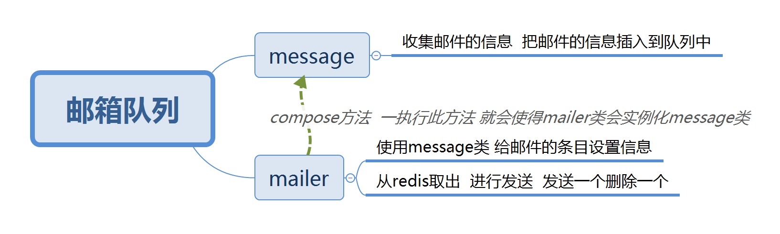

# 教程二PHPMailer思路

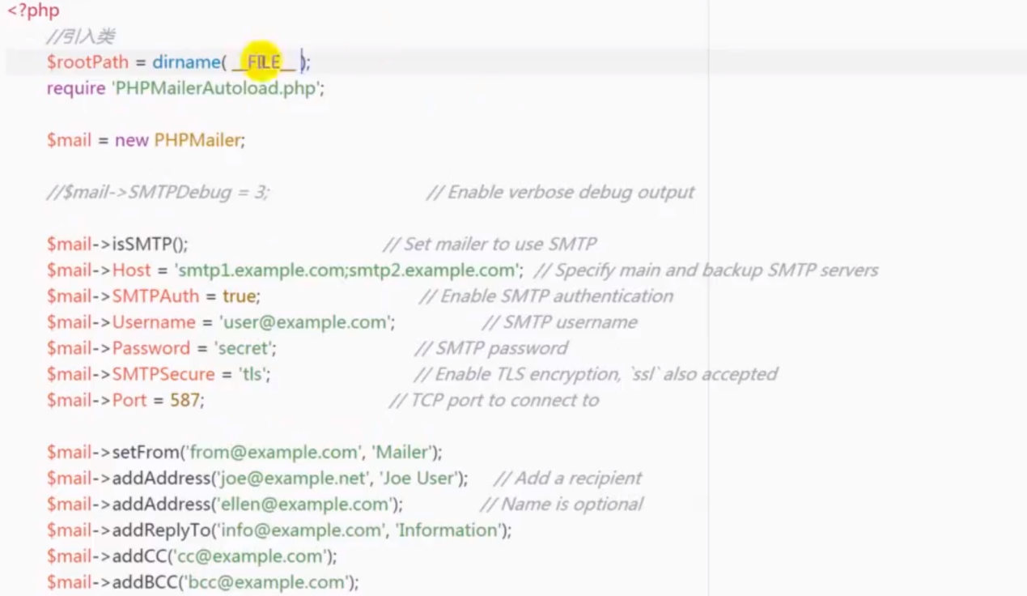

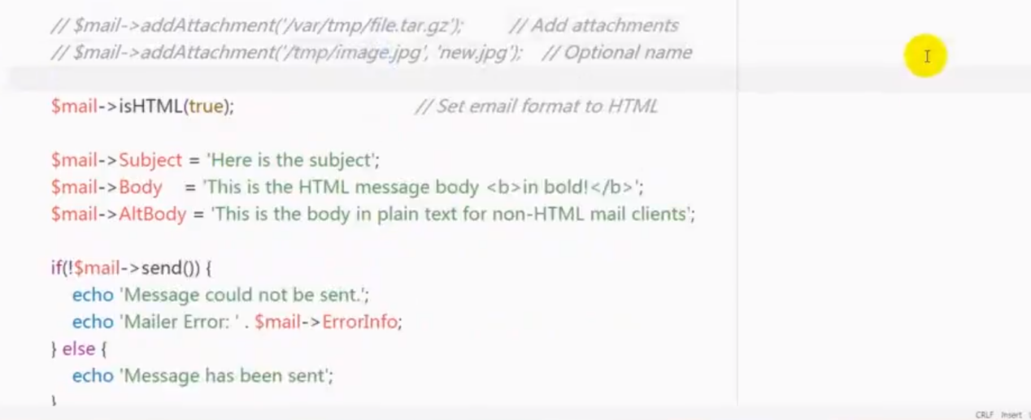

# 教程二需要队列

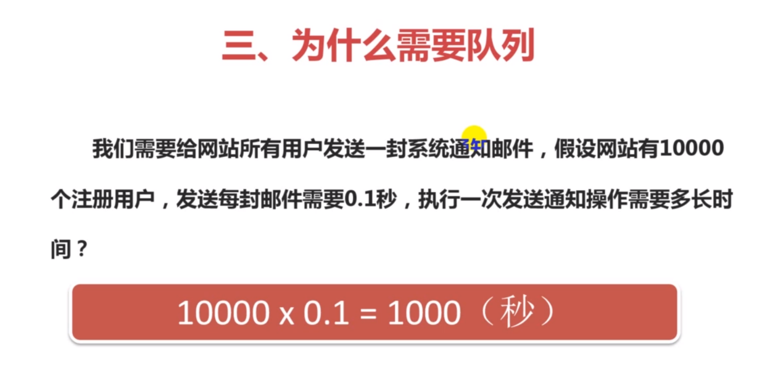

# 教程二具体过程

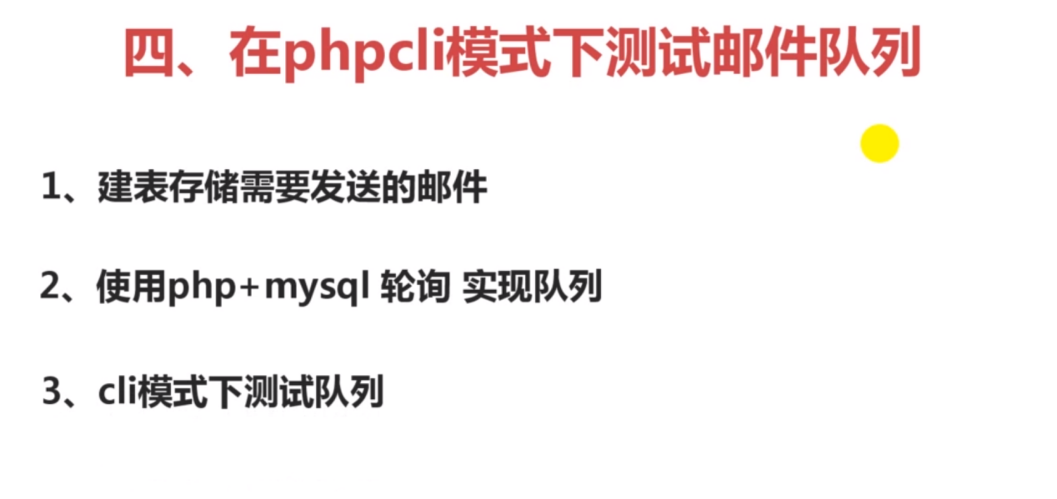

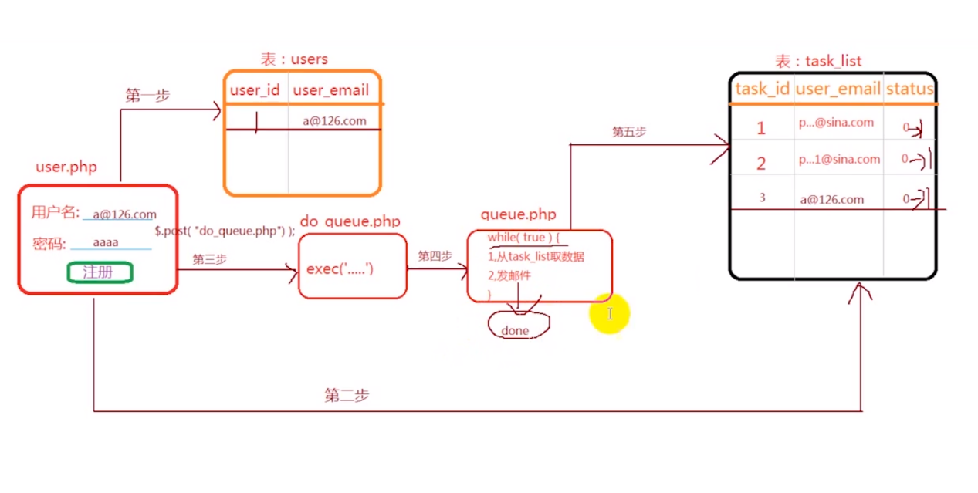

# 教程二代码

队列的代码：使用的mysql轮训的方式实现了轮训

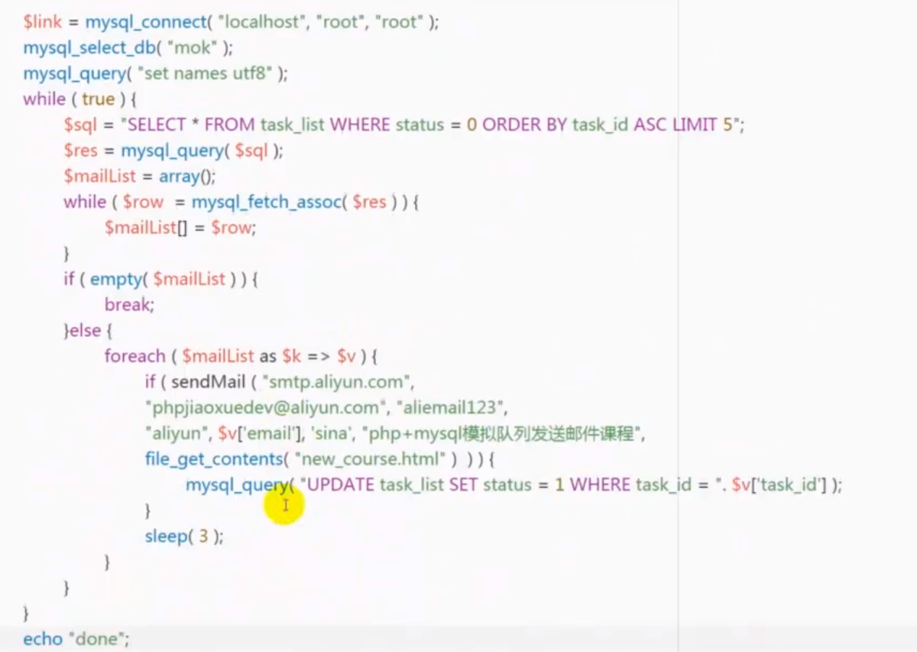

# 教程一

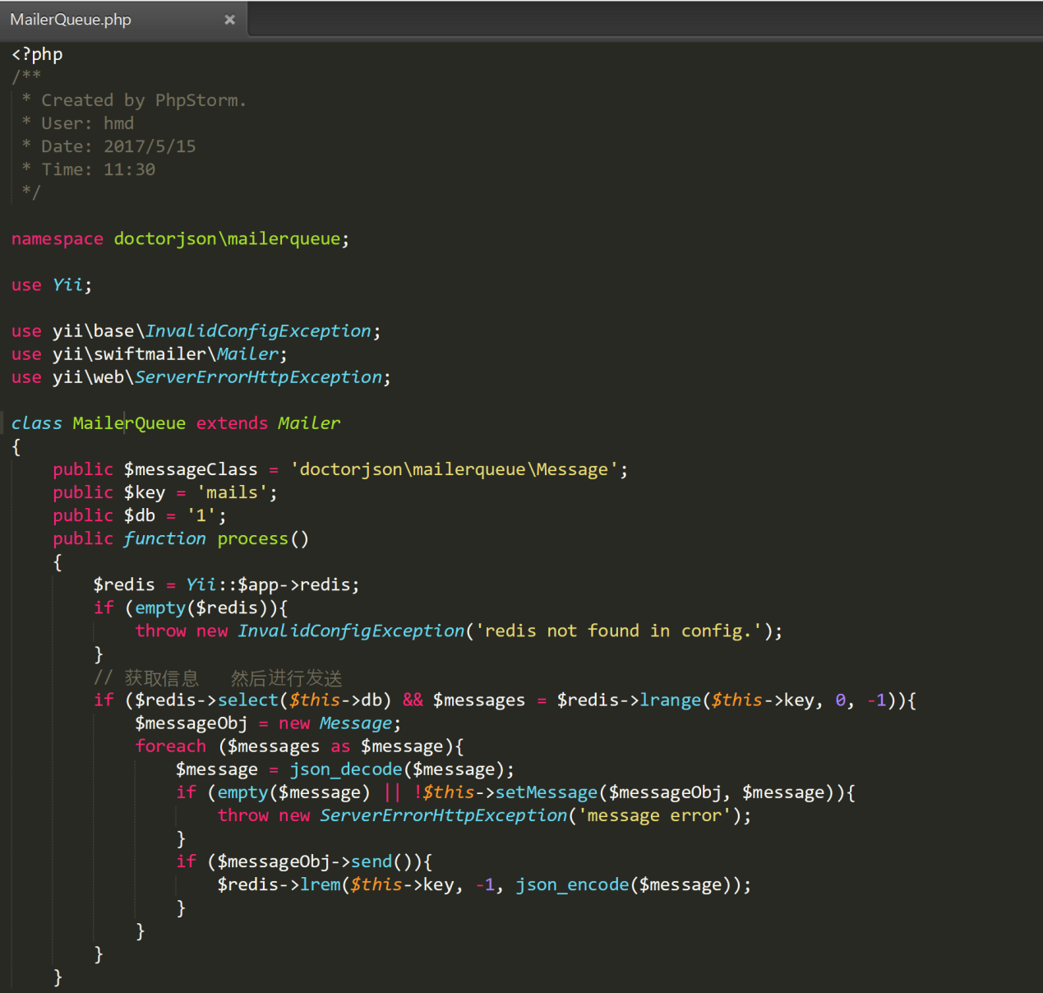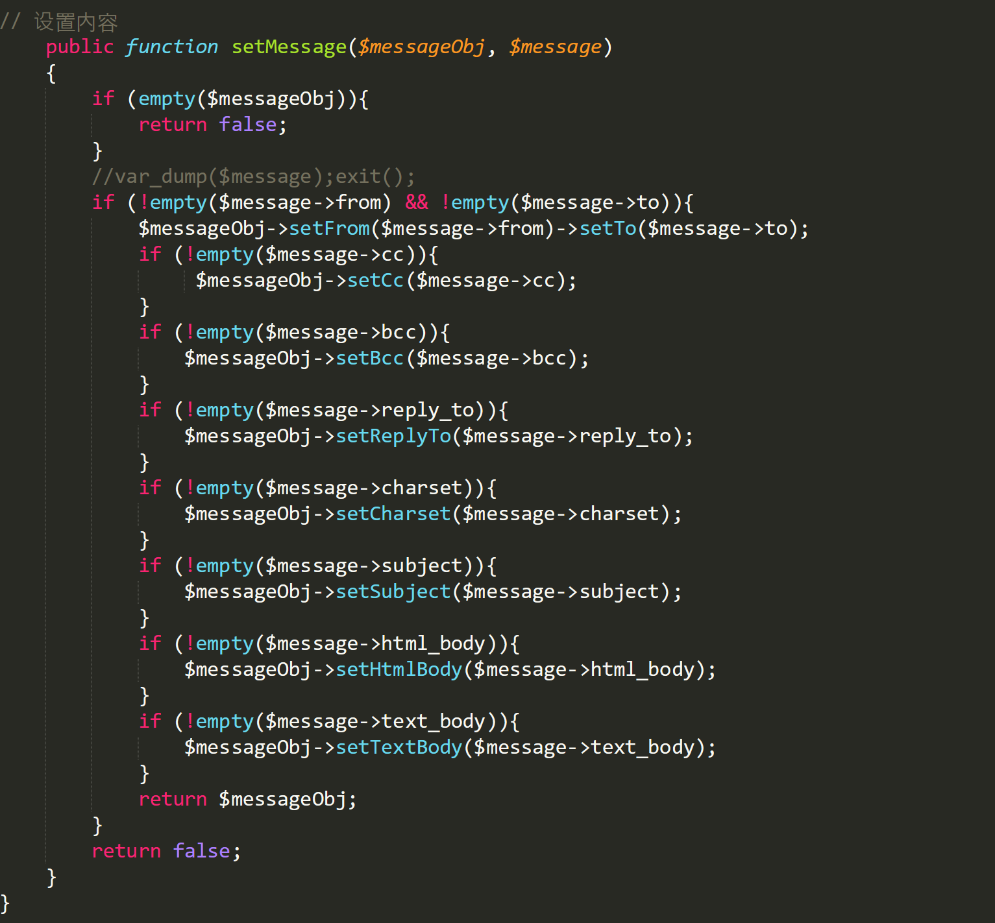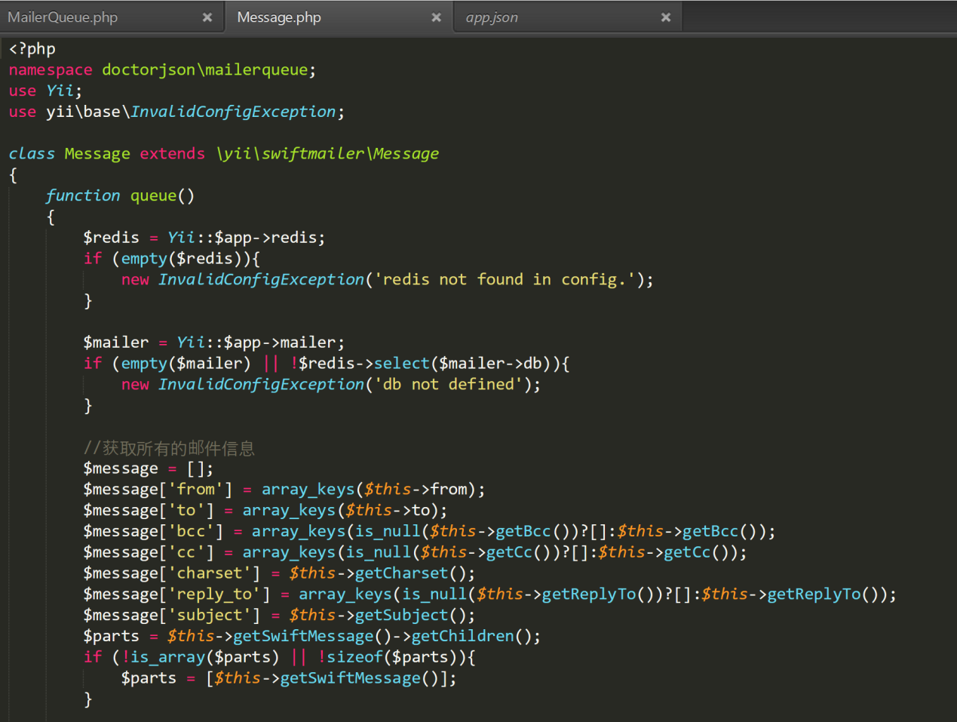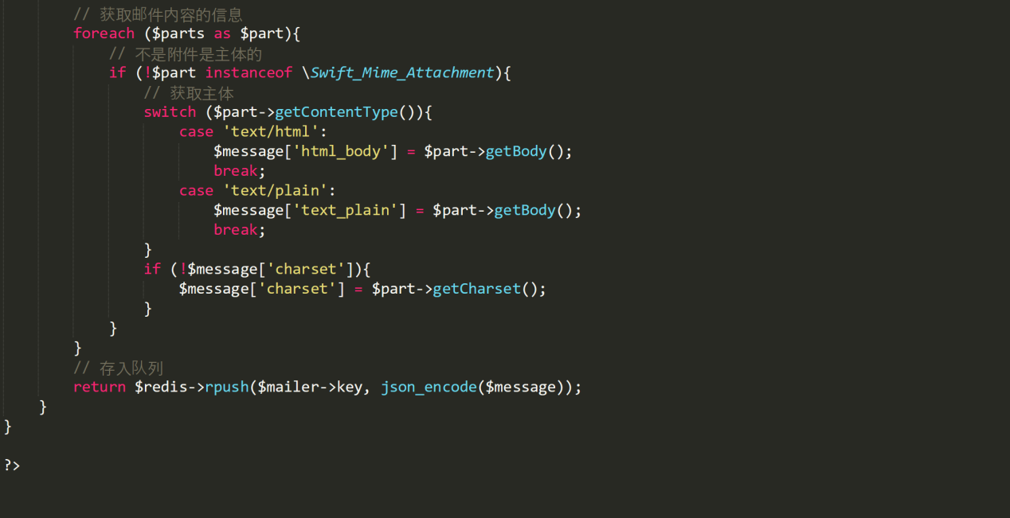

# App.json

|  |
| --- |
| {  "pages": [  "pages/home/home",  "pages/category/category",  "pages/cart/cart",  "pages/my/my",  "pages/theme/theme",  "pages/product/product",  "pages/order/order",  "pages/pay-result/pay-result"  ],  "window": {  "navigationBarTitleText": "Daily Fruit 365",  "navigationBarTextStyle": "white",  "navigationBarBackgroundColor": "#AB956D",  "backgroundColor": "#FFFFFF",  "backgroundTextStyle": "dark",  "enablePullDownRefresh": true  },  "tabBar": {  "list": [  {  "pagePath": "pages/home/home",  "iconPath": "imgs/toolbar/home.png",  "selectedIconPath": "imgs/toolbar/home@selected.png",  "text": "主页"  },  {  "pagePath": "pages/category/category",  "iconPath": "imgs/toolbar/category.png",  "selectedIconPath": "imgs/toolbar/category@selected.png",  "text": "分类"  },  {  "pagePath": "pages/cart/cart",  "iconPath": "imgs/toolbar/cart.png",  "selectedIconPath": "imgs/toolbar/cart@selected.png",  "text": "购物车"  },  {  "pagePath": "pages/my/my",  "iconPath": "imgs/toolbar/my.png",  "selectedIconPath": "imgs/toolbar/my@selected.png",  "text": "我的"  }  ],  "backgroundColor": "#F5F5F5",  "selectedColor": "#AB956D",  "color": "#989898",  "borderStyle": "white",  "position": "bottom"  },  "networkTimeout": {  "request": 20000,  "connectSocket": 20000,  "uploadFile": 20000,  "downloadFile": 20000  },  "debug": true,  "sitemapLocation": "sitemap.json"  } |

